|  |  |  |
| --- | --- | --- |
| HOLIDAY PACKAGE FOR SCIENCE SUBJECTS | MAY  MAY | |
| PLEASE ENSURE THAT YOUR CHILD REPORTS BACK TO SCHOOL WITH THE PACKAGE PROPERLY DONE. NB (IT WILL ACT AS BEGINNING OF TERM II EXAMS. PARENT’S SIGNATURE:…………………………………………………………….. | | **DIVINE S.S KITALA .** |

## DIVINE SECONDARY SCHOOL

**Uganda Certificate of Lower Secondary Education BIOLOGY HOLIDAY WORK 2023**

INSTRUCTIONS TO LEARNERS

## Try out all items

* **Respond to this work during Holiday time**

1. A senior one learner of Mpalo High school wants to do Biology at A level but he/she claims that drawings may fail him/her because he/she does not know how to make good biology drawings. Guide your this learner about does and don’ts he/she should follow when drawing in biology.
   1. Do’s (05 scores)
   2. Don’ts (05 scores)

b) This learner still needs help on how the information you provided above can be observed. Pick the jack fruit leaf from the tree draw it, showing only external features for this learner to use it to know more on the do’s and don’ts you gave him/her. Show this learner how you can calculate for the magnification of your drawing. (05scores)

1. Your parents have obtained three pieces of land in different locations especially in Wakiso, Mityana and Mukono. Three soil samples have been obtained from the lands A, B and C.

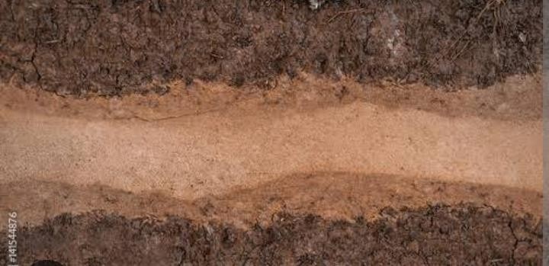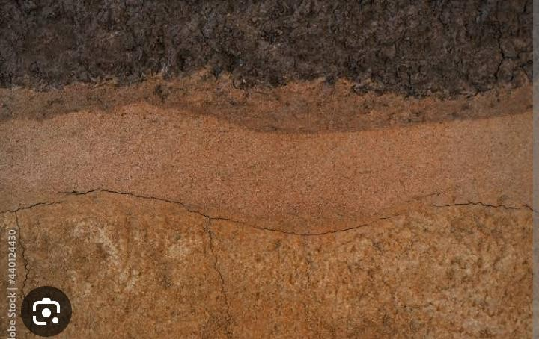

1. You are required to design an experiment to analyse the soil samples and suggest one farm where fish pond can be constructed. (10 scores)
2. Give other ways through which the farm can be put into use. (05 scores)
3. Organisms are grouped according to similarities and differences in their characteristics. Use characteristics of skins, eggs and methods of temperature regulation only. Classify Rat, Tilapia, Lizard, Hen and Toad into classes of phylum Chordata. (15 scores)

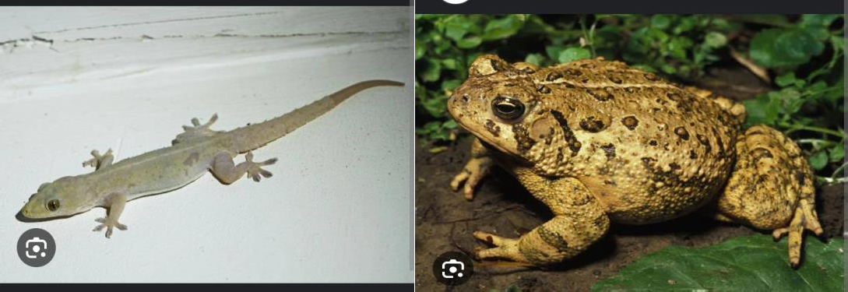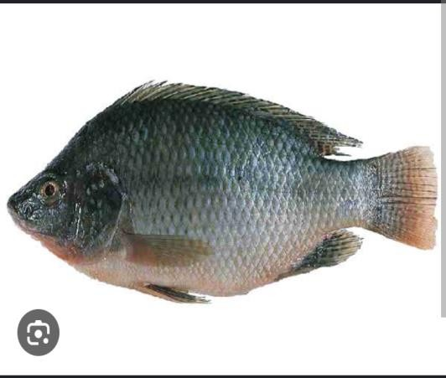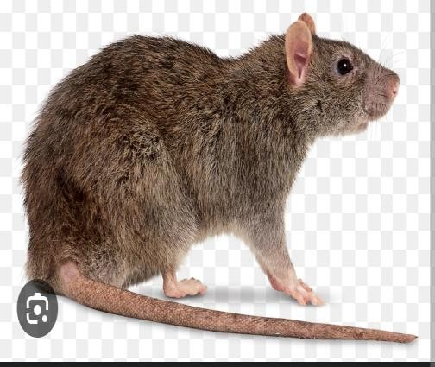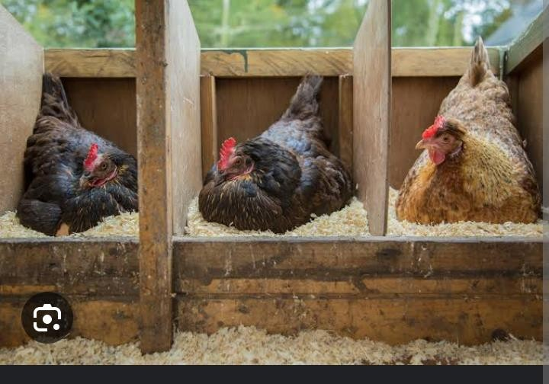

1. Your school farm contains citrus fruit plants (oranges, lemons etc). The plants are stunted with yellow leaves. They produce few small fruits. How can you and your classmate solve the problem on the school farm? (15 scores)

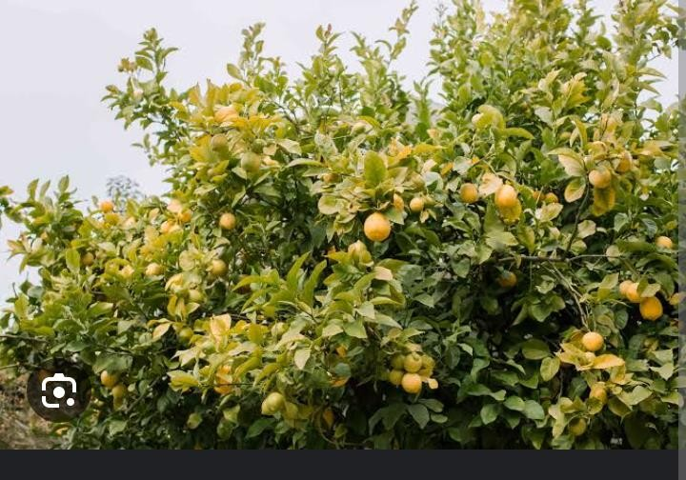

1. Mukisa farm in Mbale has been producing poor yield of crops. The newly employed farm manager Kasirye Ivan has proposed use of good seeds and other planting materials to solve the problem. Surprisingly he has proposed the distribution of good planting materials to neighbours to which the company directors have rejected.

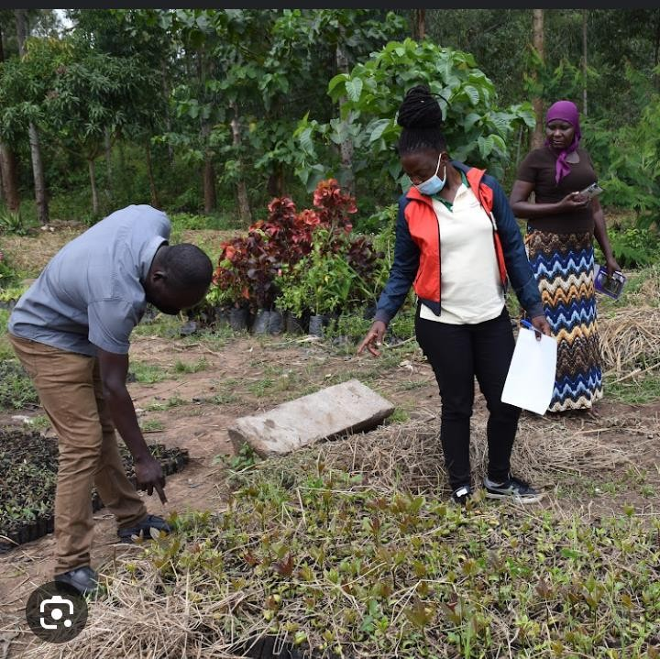

Using your knowledge of biology, explain how the strategy of distribution of good planting material to the neighbours can improve crop yield on Mukisa farm. (15 scores)

1. In analyzing plant structures, students found out numerous hair-like projections from the root. They took the plant to the laboratory and had the sketch below for one of them. These little kids had been given task to state the adaptations for some specialized plant cells and their functions but they hadn’t seen one of a kind shown on the side. Guide them on achieving their task.

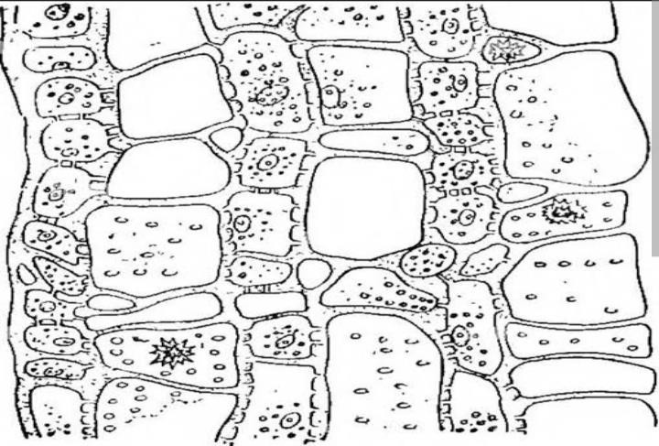

Task.

1. Name of the fine structures. (01 score)
2. Function (01 score)
3. Any three adaptations to function (03 scores)
4. On pouring salt solution on the soil particles around some plants like those shown in black around the extensions, some plants are observed to wilt and later dry. Use arrows on the drawing above to show how materials move to cause drying . Briefly describe what causes drying in such plants. (05 scores)
5. Namyalo Brenda is a young Senior one girl who lives in Mityana and goes to St. Catherine’s College Makindye in Kampala. She usually denied her mum on visitation day because of her appearance and always claimed that she is a worker at their home and warned her before her friends at school on a certain Visitation Day, never to visit her again lest she face something she would never regret. On her death bed, mum wrote to her a note that in brief read, “my daughter, your dad raped me and caused me to leave school. He fought had to force me abort the pregnancy and I refused over and over again. He one day got a pair of pliers and plucked out my teeth one by one and warned to finish them all and after to kill me had I resisted to abort. I ran from him and finally gave birth to a nice looking daughter which is you. Brenda is now studying to be a dentist. She has a photo of her mum before and after the loss of her teeth and a model for a complete set of teeth in the normal adult, together with the dental formula showing the number of teeth in the upper and lower half of the jaw.

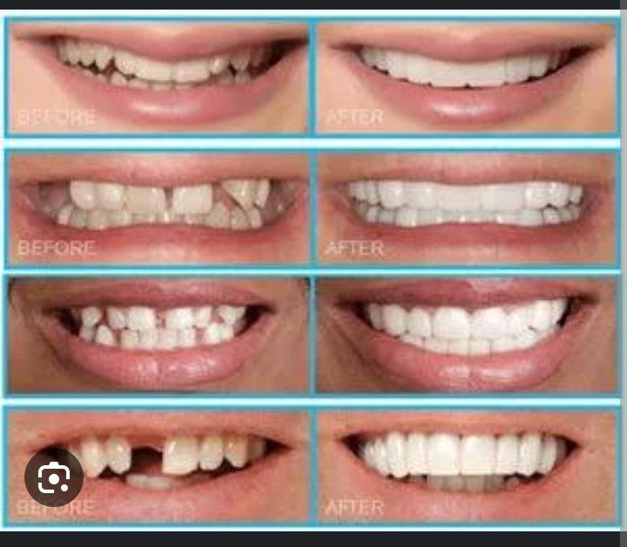

Task

As a learner who is more knowledgeable in dental care,

Write a letter to Nalwoga Lucy addressing each of the following concepts she would want to understand better.

1. Simple advice on how one can care for the teeth to prevent stigma like that mum Lucy was going through including the type of food that mum Lucy was no longer comfortable of eating after loss of some of her teeth. ( 02 scores)
2. How to identify the different types of teeth in the human oral cavity basing on their features and the function of each teeth type. (03 scores)
3. Using the dental formula given to calculate the total number of teeth in the lower and upper jaw of the mouth and after calculate the total number of teeth in the human mouth. (05scores)
4. Soil is the covering of the earth’s surface in which plants grow and some microorganisms and animals live.

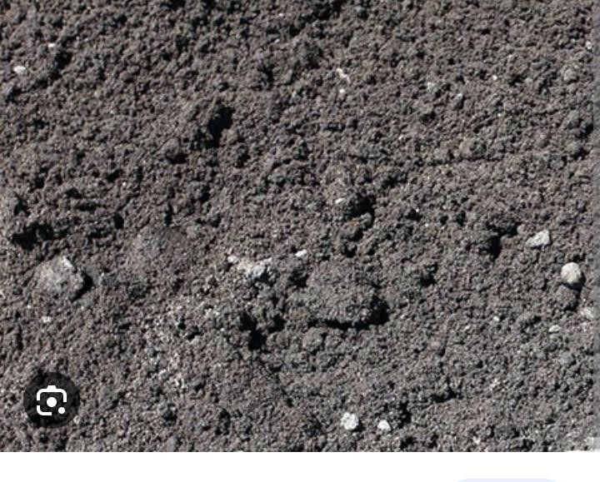

1. State any six components of soil. (06 scores)
2. A sample of soil was obtained from the school garden. It was found to contain some Micro organisms and water.

State the role played by

1. Microorganisms in the soil. (02 scores)
2. Water in the soil. (02 scores)
3. A group of senior Three Learners obtained the following results while analyzing a soil sample.

Volume of soil = 200cm3

Volume of water = 300cm3 Volume of water and sand after stirring = 450cm3

1. Determine the component of soil being investigated. (01 score)
2. Calculate the percentage composition of the above component in the soil. (04 scores)

## C:\Users\ALOKA\Desktop\WARDEN MATERIAL\Screenshot_20230723-115112.pngSupport Material

1. Determine the surface area to volume ratios of a cube of sides 2cm representing an amoeba and that of another cube of sides 8cm representing an elephant (06 scores)
2. How would the surface area to volume ratio of an elephant compare to that of amoeba? (02 scores)
3. (i) How would an amoeba benefit from the calculated surface area to volume ratio in (a) above? (02 scores)
4. Of what disadvantage is the value of the calculated surface area to volume ratio to the elephant? (02 scores)
5. How can an elephant overcome the challenges it faces as a result of the above calculated surface area to volume ratio? (02 scores)
6. Through transpiration, plants are able to get rid of excessive water from their leaves, because water vapour escapes to the atmosphere through certain routes from the plant. However, transpiration is affected by some environmental factors that either increase or decrease the rate of transpiration. You are required to identify some factors affecting rate of transpiration.



1. (i) Outline the routes through which water vapour can escape from the plant. (0 3scores)

(ii) State the process through which water vapour escapes from the leaves

(01score)

1. (i) Recall and state two conditions that easily dry clothes when we wash and hung our clothes to dry. (02 scores)

(ii) How do you think one of the conditions help to dry clothes? (02 scores)

1. (i) Using that knowledge from (b) above, State three factors that can increase the rate of transpiration. (03 scores).

(ii) Explain the Importance of Transpiration to man (05 scores)

1. Learners of Senior three were told when they go back home after lessons, they look for an animal and caught the Animal. One learner realized that the body of the animal is divided into two parts, simple eyes and eight legs
2. State the class to which the Animal belong too (01 score)
3. Suggest the phylum and its characteristics to which the Animal belong too.

(04 scores)

1. Oil can be applied on the stagnant water to control the spread of malaria.

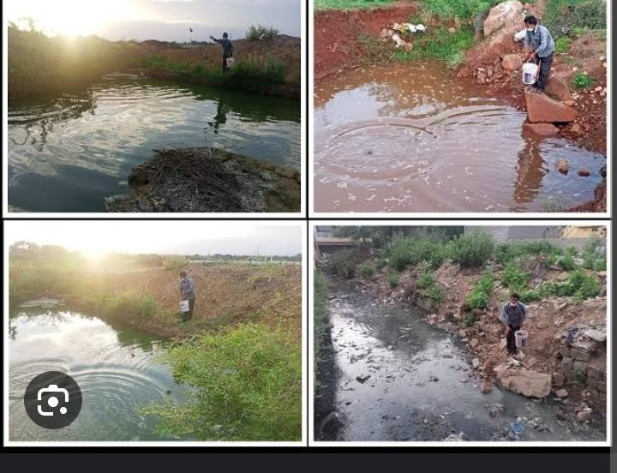

(a) How does this practice control the spread of malaria? (03 scores)

(c) Propose one method which is scientifically more acceptable for controlling malaria. (02 scores)

1. Senior one learners observed bread mould using naked eyes and then using microscope. The results were shown below.

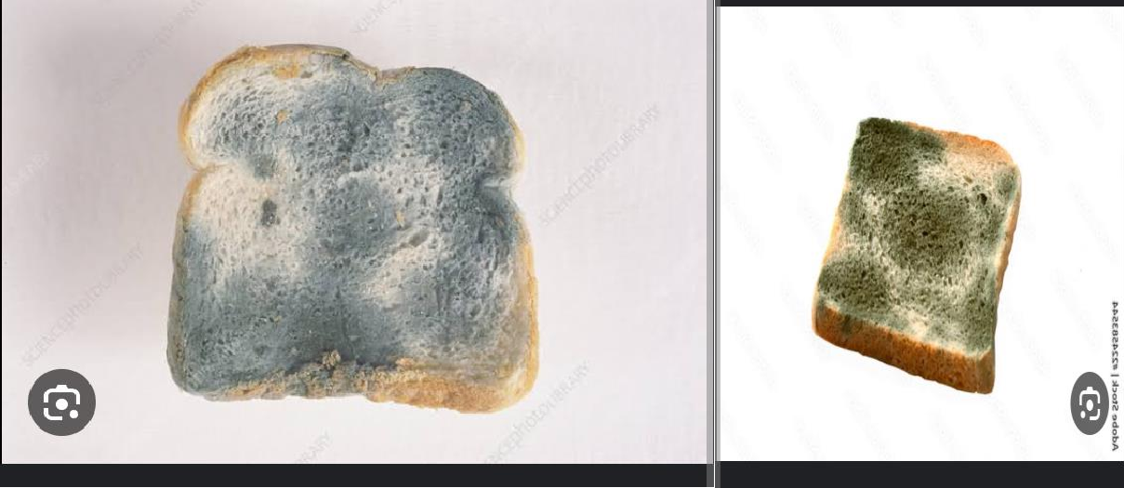

1. Why do you think mould grow on bread? (01 score)
2. What are the dangers of eating food with mould? (02 scores)
3. Give two economic importance of organisms which share kingdom with bread mould. (02 scores)
4. A learner put a spatula end full of soil in a clean test tube, and then added water to just cover the soil. The student then added 5 drops of universal indicator and had to shake thoroughly and filtered the mixture into test tube. The procedure was repeated with other more two soil samples.



1. Identify the property of the soil being investigated? (01 score)
2. Suggest how the student used the filtrates to determine the property of the soil mentioned in (a) above. (02 scores)
3. What is the importance of testing the property of the soil to a farmer?

(02 scores)

1. Move around the Parents home or your village during your Holiday and pick different leaves, obtain the leaves from different plants like from whole bean plant, Cassia plant and Cassava plant while picking observe the whole plant you may use it to respond to an Item. Study the leaves carefully you picked and respond to the Items.

(a)Use observable features to classify each of the leaves you picked. (05 scores)

b) While picking the leaves you observed that a plant comprises of different parts that have different functions. State parts of a plant with their function(s).

(05 scores)

1. In the recent years, Magogo Village started developing at a very high rate. Most of the people in that village have been employed in the newly established paper processing industry, Diary processing industry, Oil refinery and charcoal burning. During a heavy rain, the big portion of land of Magogo region was observed to have developed very big tunnels that even started to accommodate large volumes of water.

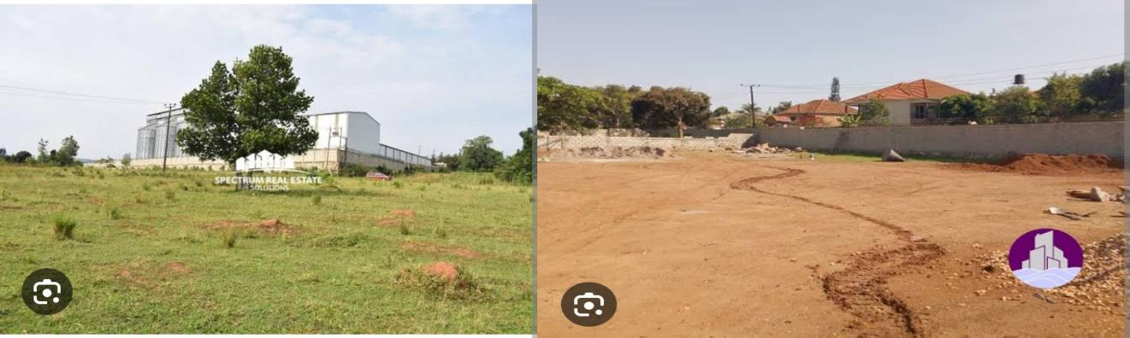

1. Identify the process that caused the development of tunnels in the soil.

(02 scores)

1. What could have caused the land of Magogo to appear in that way after heavy rain. (10 scores)
2. How can you advice people of Magogo such that rest of their land is not affected the same. (08 scores)
3. Malaria is the leading disease that affect people mainly in the tropics. It is caused by organism **Z** that is transmitted by the female anopheles mosquito.

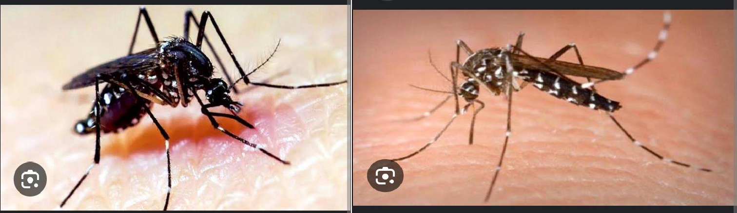

1. Identify organism **Z** and state why it mainly affects people from the tropics

(03 scores)

1. Why is organism **Z** transmitted by the above mentioned vector? (02 scores)
2. How would you advice people from your community to avoid dangers of malaria. (10 scores)
3. In most parts of Uganda, Farmers have always complained of decreasing fertility of the soils leading to poor yields that decreasing food production in their respective areas.



Task

From the knowledge of the five kingdoms of living organisms, write an essay on how organisms from different kingdoms can interact their environment to increase food production.

1. The Uganda Wild life would like to establish a tourist center on the shores of lake Bunyonyi in South-Western Uganda. They have conducted a feasibility study and identified a suitable site where to create the center.

At their center, they wish to put two sections. **Section A** where they would keep different animals found in Uganda and **section B** a botanical garden would be established including a pond where acquatic organisms would be kept. However, after preparing the center they were faced with challenge of stocking the Animals and Botanical gardens with relevant in kingdoms Plantae and Animalia that would attract tourist to the center in order to raise fund to maintain the place.

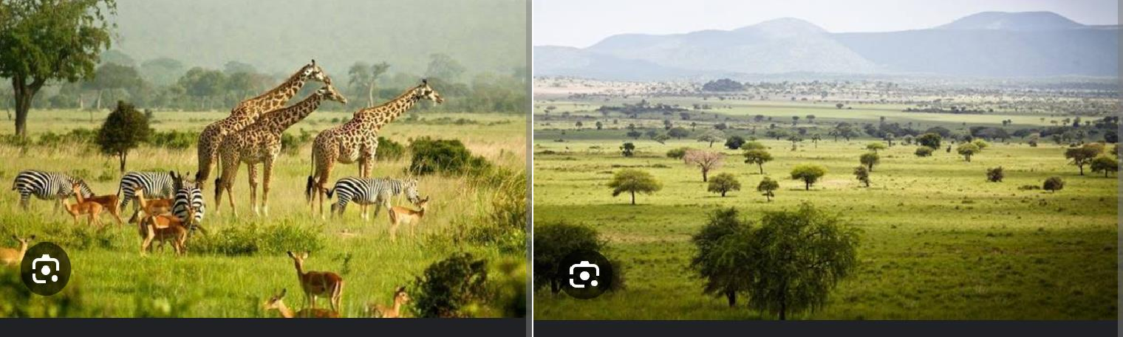

Task

As a learner of Biology, you have been asked by the Uganda wildlife Authority for advice on how to select examples of relevant Organisms that would be stocked at the center from two Kingdoms for example Kingdom plantae and kingdom Animalia.

1. Organisms require gases to run some processes. For animals, they require oxygen which is usually obtained from their environment. Man uses the respiratory system to take in this air that contains the oxygen needed from the

atmosphere. Through answering the Items below, you will be to learn more about the process of breathing and gas exchange.

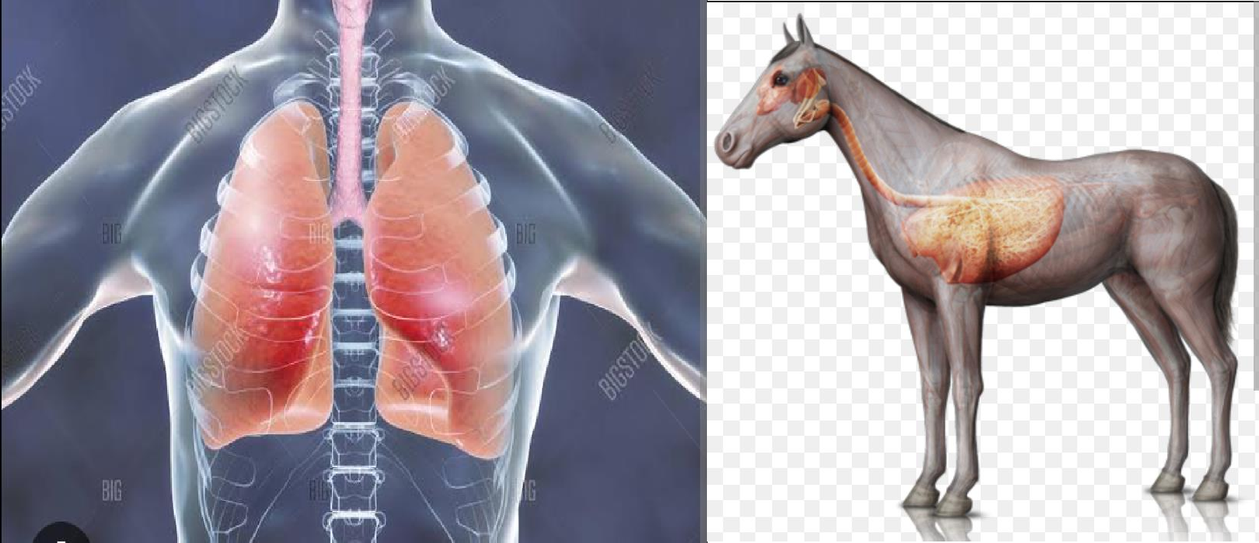

1. Mention any four organs that make up the respiratory system of man.

(04

scores)

1. (i) From the organs mentioned above, state the exact organ or structures through which gases are exchanged. (01score)
2. What is the difference between the function of the nose and lungs (02scores)
3. What do plants use for breathing? (01score)
4. During breathing, the following processes occur in the body so as air can enter man. The volume of the chest increases. Air reach in oxygen enters through the nose and travels to the lungs. Intercostal muscles of the rib cage contract. Pressure of the chest decreases below atmospheric pressure. The rib cage moves upwards and outwards. The above process is not in its order.

You are required to sort and organize the above process in its normal flow for breathing to occur. (05 scores)

1. Explain why breathing is very important to animals. (02 scores)
2. Mrs. Aloka is a good farmer who uses the knowledge she obtained from studying transport in plants to grow tomatoes for her home consumption as souce and at times making juice. In the process of growing tomatoes, she prepares a nursery bed for growing the tomatoes to a certain stage but later transplants them in the late evening hours to the main garden.

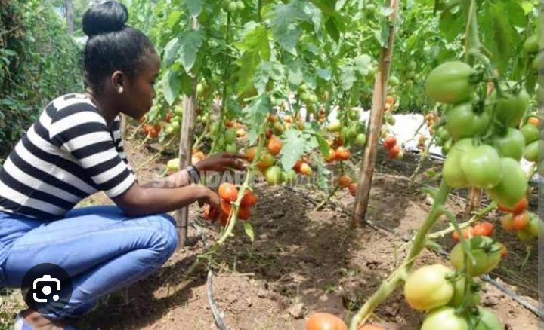

1. (i) Why do you think Mrs. Aloka transplants her seedlings in the late evening? (02 scores)

(ii) After transplanting the seedlings, Mrs. Aloka keeps on watering the main garden until a certain stage. Explain why she waters the garden. (02 scores)

1. (i) Which process do you think plants use to take up the water Mrs. Aloka provides to them? (01score)
2. Name the cells that enable these tomatoes to absorb water. (01score)
3. Which cells do these tomatoes use to transport water and mineral salts from roots to leaves such that they can use the water. (01score)
4. How is the process stated in b) (i) above useful in animals? (03 scores)
5. (i) Explain what makes water to enter the roots of the plant. (02 scores)

(ii) How do you think roots are adapted to absorb water from the soil solution? (03 scores)

1. At breakfast and evening tea, your school provides milk and cooked cassava to the learners as suggested by the government of Uganda .

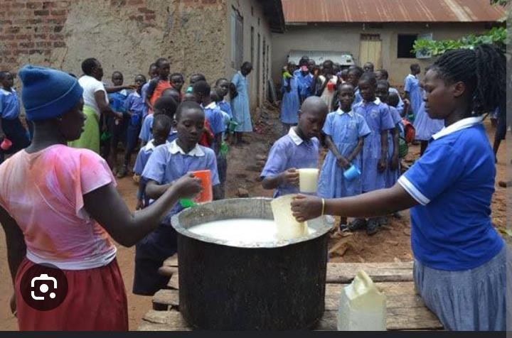

1. Name the food nutrients that the school mess provides to its learners at breakfast. (02 scores)
2. Some learners after eating this kind of food, they complain of over dosing and end up missing lessons due to sleeping in class. Explain why do learners dose after having some meals. (02 scores)
3. (i) State all the enzymes in the body that enables the learners to breakdown the food substances they are provided at breakfast. (03 scores)
4. Name the end products of the foods they get at breakfast. (02 scores)
5. How is glucose used in the body of organisms? (03 scores)
6. After digestion, the products mentioned above are absorbed in to blood system by the ileum and the colon. State three ways in which the ileum is modified to absorb these materials. (03 scores)
7. Read the passage below and use it to answer questions that follow.

Your immune system is what protects you when germs try to invade and attack on your body which can cause you to become sick. Your body has microscopic warriors that fight invasive germs and help your body get rid of them. Your body is pretty good at defending you against the jams. Your body systems are your first line of defense against germs. For instance, the skin tries to stop germs from entering the body, the lungs, saliva and the digestive system all try to trap germs to destroy them or to help them exit your body. Your blood also tries to destroy harmful germs. Think about when you sneeze your body is trying to get rid of something that got into your nose!! If this first line of defense does not work, there is also a second line of defense that helps fight harmful germs in order to keep you healthy.

Your second line of defense is when your body makes antibodies that help kill or destroy harmful disease or illnesses causing germs. These antibodies that your body creates are actually proteins that go on the attack when your body gets harmful germs that are not supposed to be a part of bodies of your body. Think about when you get a cold or a flue. Your body works hard making antibodies that will destroy the cold or flu Germs, when they are successful you begin to feel better. Vaccinations act in a similar way as they contain antibodies as well. The antibodies in the vaccinations help prevent disease and illness like measles, chicken pox and specific types of flus. It is also important to live a healthy lifestyle by eating nutritiously and getting exercise daily to boost your immunity.

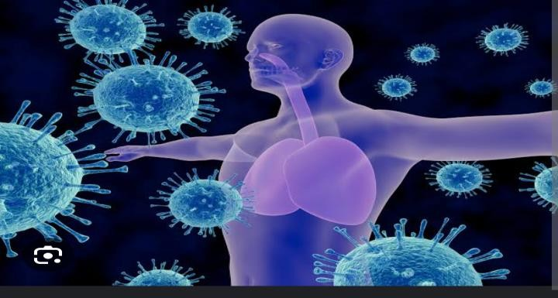

1. (i) Define immunity using your own words. (02 scores)

(ii) Describe how your body fights against germs. (02 scores)

1. (i) What would happen if you had no immunity? (01score)

(ii) How do vaccines assist with immunity? (01score)

1. Describe how the following help in immunity.
2. Mucus (01score)
3. White blood cells (02 scores)
4. Sneezing (01score)
5. State how the following acquire their immunity:
6. Embryos (01score)
7. Babies. (01score)
8. Explain how immunization or vaccination provided immunity of the body.

(03 scores)

1. a) Mr. Akutex bought land which was being used by the person from whom he bought the land. Mr. Akutex decided to plant maize crops for his family but he observed the following features on leaves in his plantation after planting.

* Stunted growth
* Yellowing of leaves
* Poor root and fruit development
* Premature death of plant parts.

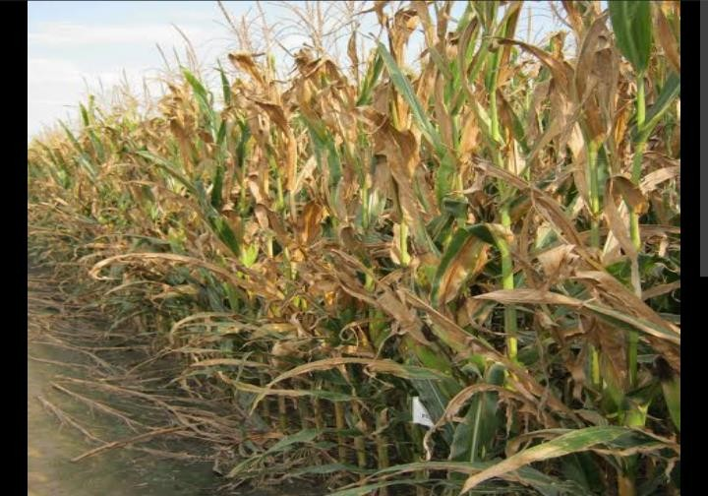

1. Which mineral elements do you think were deficient in the soil? (02 scores)
2. Which advise can you give to Mr. Akutex about deficient elements?

(02 scores)

1. Name the farming practices the former land owner could have used that might have caused to the exhaustion of these particular elements. (02 scores)
2. When he realized that, Mr. Akutex decided to also determine the soil air content. In the investigation, he obtained the following results though he faces challenges with calculations involved in soil:

Volume of soil = 30cm3

Volume of soil and water before mixing = 70cm3 Volume of soil and water after mixing = 75cm3

* 1. Help Mr. Akutex to determine the percentage of air in his soil.

(03scores)

* 1. Comment on the aeration of Mr. Akutex’s soil. (01score)
  2. Which advice can you give him to improve on the aeration of the soil?

(03 scores)

1. What is the usefulness of a better soil aeration to the plants? (02 scores)
2. Mr. Kabaale Edward is a farmer in Magogo village . He has a bee hive in the middle of his garden on a mango tree which bears a lot of ripe fruits. In the same garden, there are many flowering plants including beans, maize and sweet potatoes. Learners from a neighboring school and some members of the village trespass into his garden to eat the ripe mangoes. is annoyed and fed up of this act by students and villagers and he is wishing to cut down the mango tree .

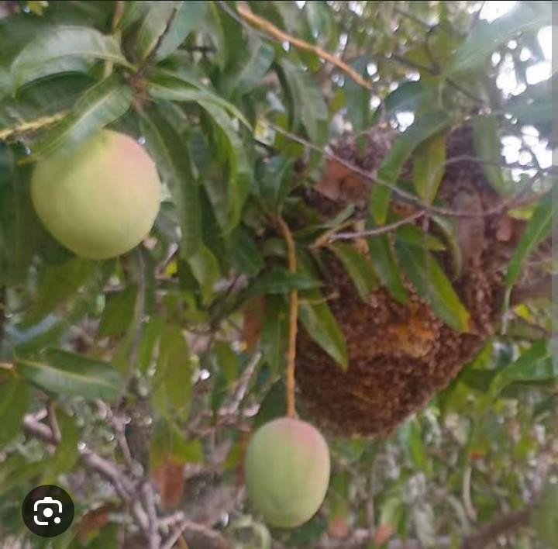

## TASK

In not more than 500 words, Use your knowledge of life processes. Write a letter to Mr. Kabaale Edward explaining to him the different interactions of organisms that he will destroy once he cuts down that mango tree. Give him advises on why he should not cut down the mango tree.

1. A learner of St. Catherine’s College Kakooza Hamza who is feeling thirsty sees a bottle of water on the table. He picks and drinks the water.
2. What are the actions involved in the process of picking the bottle of water to the mouth? (12 scores)
3. Explain why a dog which has lost its senses stops being useful in defending the home? (3 scores)
4. A family bought a piece of cultivated land on a hilly place.

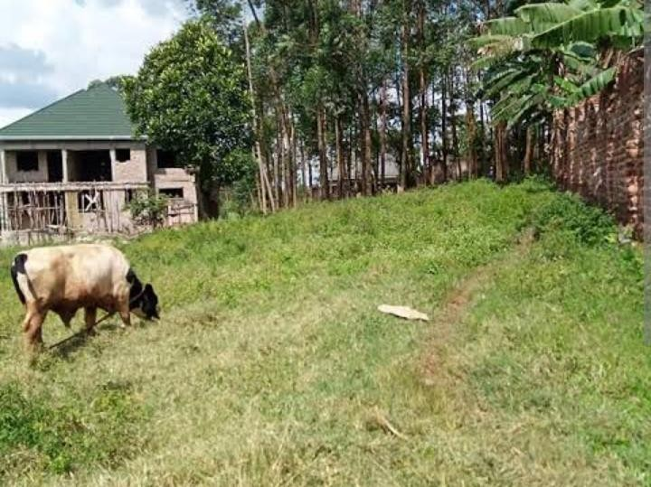

1. Describe the problem that the soil would experience during a rainy season.

(3 score)

1. What advice would you give to this family to reduce the problem on their land? (12 scores)
2. Nalwanga Madrine’s father asked his daughter to get involved actively in biology lessons so that she does not forget the concepts easily.

a) Give five reasons why Madinah’s father was encouraging his daughter to concentrate in biology (05 scores)

(b) Mawanda Simon carefully cracked an egg and carefully poured out the contents in a clean Flat white plate, after thorough observation, he concluded that it was an animal cell,, give five reasons why Mawanda concluded that it was an animal cell (5 scores)



1. A community in Uganda, is cutting down trees in a nearby forest to create new space for farming because food yields from the land they are currently using has declined. A government authority has stopped them from clearing the forest. The community members see no reason why they should be stopped.

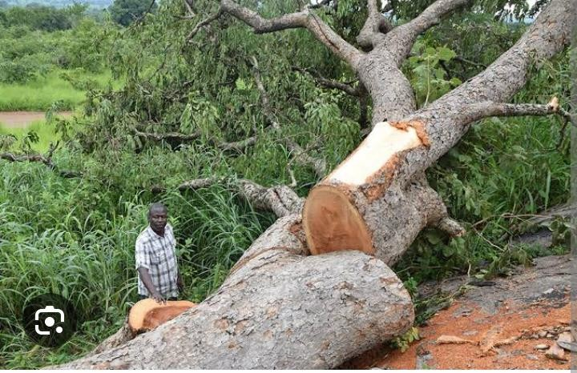

1. What general term or phrase would be used to refer to what the community is doing to the forest? (1score)
2. Write an essay to the community which will make them to appreciate the government’s action and how they can stay on their current land. (14 scores)
3. At Masajja Kibira B a teenage girl living with HIV who is on treatment has been Pregnanted by a teenage boy. The teenagers have become the talk of the community.



1. What is the possible talk about the teenagers by the people of Masajja Kibira B? (03 scores)
2. What challenges are faced by the teenagers from the talk? (06 scores)
3. Suggest ways forward to help the teenagers. (06 scores)

## END

**DIVINE SECONDARY SCHOOL**

## Uganda Certificate of Lower Secondary CHEMISTRY HOLIDAY WORK 2024

INSTRUCTIONS TO LEARNERS

## Try out all items

* + **Respond to this work during Holiday time**

1. Charcoal burning is one of the sources of income and the main source of fuel in Uganda but recently charcoal burning has attracted a national concern where the majority of people are against it. Explain the effects of this economic activity and how it can be prevented.

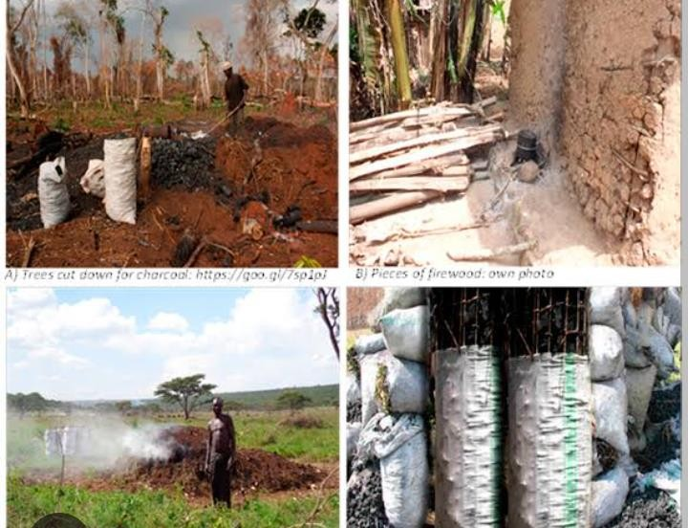

1. People have encroached wetlands in search of land for settlement and setting up industries. This has caused major problems to the country and promoted the government to campaign against wetland encroachment.

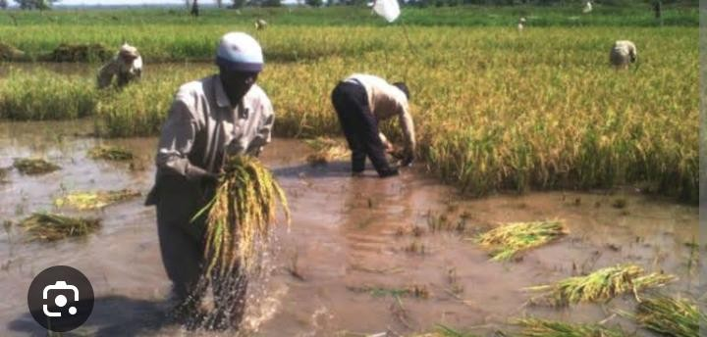

## Task

As a learner of chemistry, write a speech explaining to your community why the government is against wetland encroachment.

1. In the Village of Mabuuye people are involved in certain activities which lower the quality of water unknowingly and these include; washing near water bodies, Agriculture near Water bodies and setting industries.



## TASK

As a learner of chemistry, use the knowledge of water acquired to explain to the people of this village to overcome the problem of lowering the quality of water.

1. Below is an article extracted from the New Vision of 07th / May/2022. The website to which it was downloaded has been provided at the end of the article. Read the article carefully and answer the questions that follow. **TOP STORY**

‘’Air pollution killing more than HIV’’ -New vision official**. Gerald Tenywa. Journalist @New Vision.**

Every home in Uganda has either been infected or affected by HIV and AIDS. They have either lost a relative or have suffered as a loss of a bread winner. Air pollution has gone steps ahead of HIV in affecting Ugandans as it has claimed more lives than HIV, Daniel Okello , the director in charge of environment at Kampala Capital City Authority (KCCA), has said. “We lost 23,000 People in 2019 due to HIV in Uganda. In the same

period, 26000 People died as a result of cardiovascular diseases linked to air pollution,” he said. Okello was speaking during the launch of the air quality awareness week at the Uganda Media Centre in Kampala on 4 May 2022.

The event, **themed** “Be air aware, be prepared" ,attracted top officials from the National Environment Management Authority( NEMA), Makerere University and Ministry of Health, who called for increased awareness and actions to curb air pollution.

Okello mentioned of two types of air pollution -outdoor pollution and household or indoor pollution which are all greatest environmental threat to human health around country pointing out Kampala, Mukono and Jinja with the poorest air quality which is five times way above the critical threshold of World Health Organisation.

Okello said indoor air pollution resulting from cooking with biomass fuel particularly charcoal, firewood, coal ,burning of organic fuels such as kerosene, burning of grass and waste products. Partial combustion of these fuels lead to emission of carbon monoxide gas, which is poisonous if inhaled. Worse than indoor air pollution, he added, is outdoor air pollution include old cars spewing fumes. As the cars burn fuels, such as diesel and petrol to power engines, they release poisonous gases such as carbon monoxide and also lead from motor vehicle emissions, dust from unpaved roads and construction sites, factories release fumes filled with sulphur dioxide gas which leads to acid rains and carbon monoxide gas which is poisonous .Burning of wastes including plastics , produces dioxins and furans, which cause cancer.

Dr Ivan kimuli from Makerere University’s lung institute said they have done studies that indicate that 11% of the population suffers from asthma and that was being aggravated by poor air quality and the same study indicated that children in rural settings had “ better and less damaged lungs" than those in urban settings, who were exposed to pollutants in the air. NEMA's director for environment monitoring and compliance, Waiswa Ayazika, said: “ the government is currently making a clear plan

to improve air quality involving every body's responsibility to save the current and future generation.” [**http://www.newvision.co.ug/category/health/air-pollution-killing-**](http://www.newvision.co.ug/category/health/air-pollution-killing-) **morepeople-than-hiv-133316**.

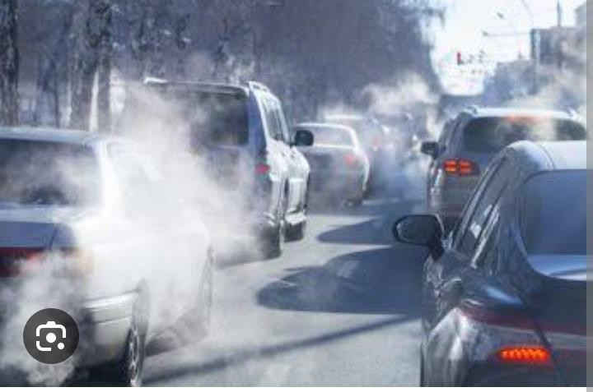

(a).State what is meant by the term “air pollution" ? (02 scores)

(b)From the article; state the different types of air pollution and outline how each type of air pollution is caused. (08 scores) (c)From the article, state the main air pollutants and show their effects to man. (08 scores)

1. Suggest a reason why Kampala, Mukono and Jinja have the poorest air quality which is five times away above the critical threshold of World Health Organisation? (02 scores)
2. Suggest any 5 solutions that can be adopted into the government’s strategic plan of how air pollution in the country can be greatly reduced

(05 scores)

1. A Senior two Learner from St. Catherine’s college carried out an activity to obtain juice from a fruit.

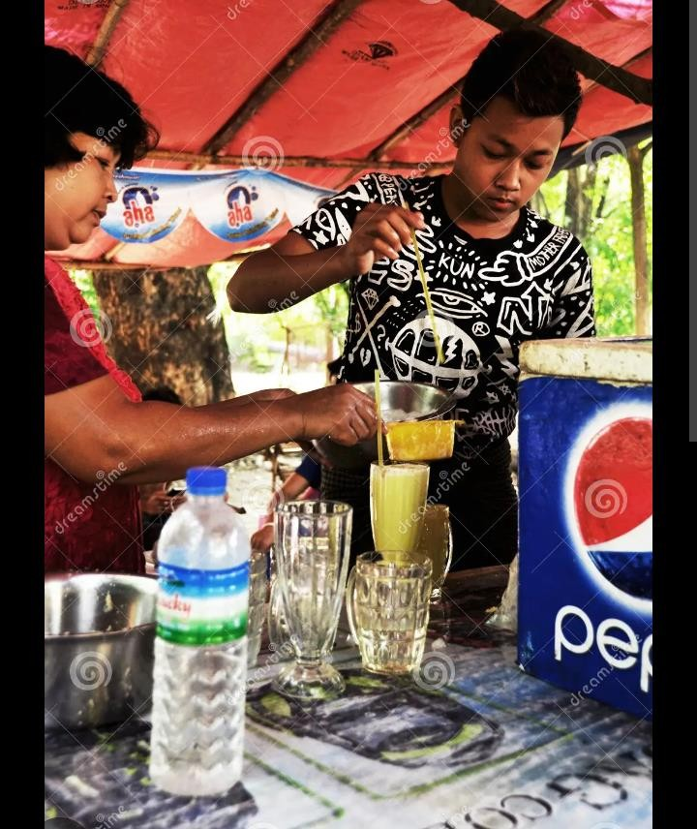

* + She Cleaned the fruits by washing using clean water.
  + Peeled the fruits to remove the unwanted parts including seeds.
  + Placed the fruits into the blender and blend them to a liquid solid mixture Removed the mixture from the blender and filter off the solid parts of the fruits using a kitchen sieve.
  + Add some water while filtering.
  + Added some sugar to improve on the taste of the juice.
  + Packaged the made juice into clean dry bottles.
  + Gave the juice made a name.

## Tasks

1. Identify the ways how she can improve on the quality and safety measures of the juice in terms of color, taste and stability. (8 scores)
2. Identify the substances that can be added to make the juice suspension stable.

(3 scores)

1. In the last 30 to 40 years, plastics have taken over as replacement materials for metals, glass, paper and wood as well as for natural fibres such as cotton and wool. However, plastics such as polyethene bags have contributed significantly to household waste problem, up to 10% in some countries, and it is getting worse.

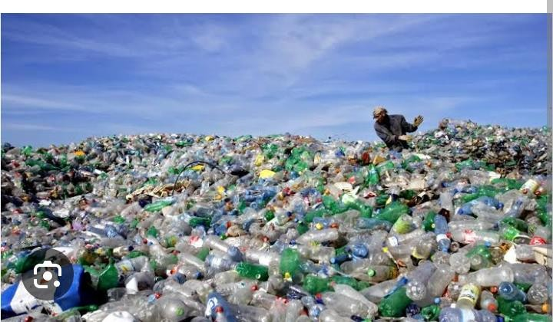

1. Outline any three advantages of using polyethene packaging (3 scores)
2. Explain any three ways how polyethene bags are dangerous to our environment (06 scores)
3. Explain any three ways of how to prevent the effects of polyethene bags on the environment (06 scores)
4. The National Environment Management Authority (NEMA), has organized a two days’ students workshop to take place at Rock Classic Hotel – Tororo to discuss key issues concerning about conservation of environment. On day 1, the Programme drafted on paper has a key statement to be addressed which reads. “Today’s society in view of modernization has neglected the mother nature of water, which has ultimately cost us on health. This needs urgent solutions”.



Prepare a speech you would deliver at the workshop about the key statement

(15 scores)

1. In our day to day life at home most of us use carbon compounds such as petroleum products, wood, charcoal and biogas as source of fuel. Research shows that continued use of these fuels has greatly affected our resources from which they are obtained.

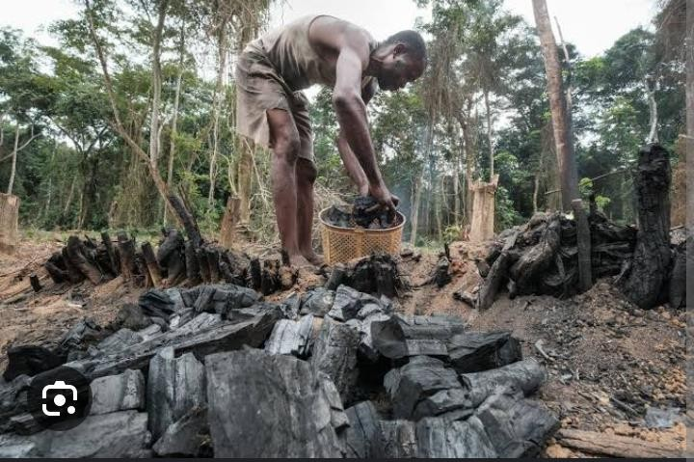

1. Explain any six (6) ways how we can sustainably use the available resources

(12 scores)

1. The main component of biogas is methane (CH4). Methane is the simplest compound obtained from crude oil which contains a variety of compounds but with similar structures.
2. Identify the class and write the general molecular formula of the organic compound to which methane belongs. (02 scores)
3. Name and write the structural formula of the next member of the organic family after methane (01 score)
4. Large deposits of oil have been discovered in Lake Albert near Hoima city. Crude oil contains a variety of different compounds but with similar structure. The simplest of these compounds is methane of molecular formula CH4 and many others.

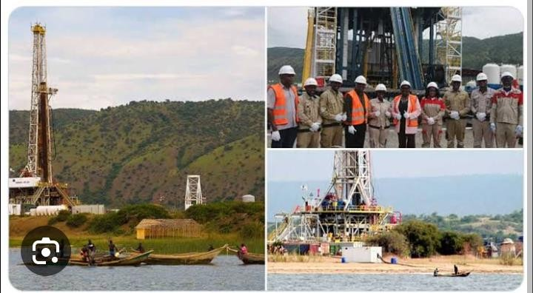

1. Identify the class and write the general molecular formula of the organic family to which the components of oil belong (04 scores)
2. Name and write the structural formula of the next two members of the organic family named after methane (04 scores)
3. Giving a reason for your answer, state one method by which the components of crude oil. (2 scores)
4. Mukhama Garvin loves drinking rain water because he believes it is pure water as he gets directly from the sky. However, Owen Micheal has continuously advised him to stop taking it and instead drink water from the borehole which is hard water.

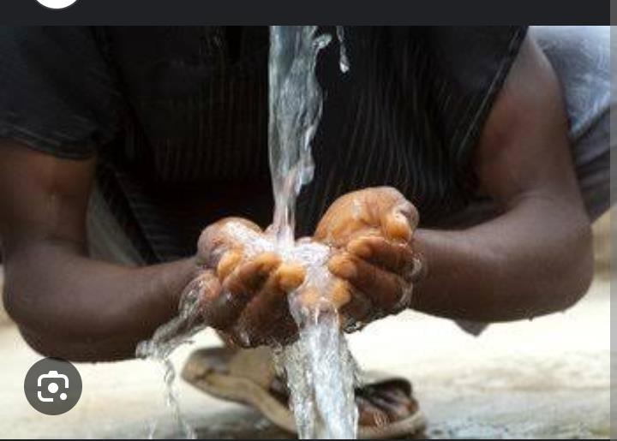

1. Why do you think Owen Micheal advises Mukhama Garvin to drink hard water? (02 scores)
2. Hard water is used to wash clothes more soap is required while less soap is required if rain water is used. Briefly explain this observation. (03 scores)
3. In a certain school, the latrine is near senior one class. The foul smell disturbs the students in the class and the smell becomes much more on the hot day.

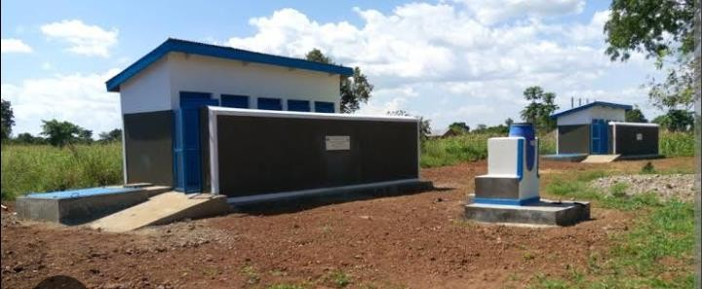

1. Explain briefly how the smell molecules are able to move from the latrine up to the classroom. (02 scores)
2. Explain why the smell from the latrine become much more during the hot day.

(03 scores)

1. Salts are very important in our everyday lives as some of them are used in medicines, add taste to our food. Many of these salts can be prepared in the laboratory.

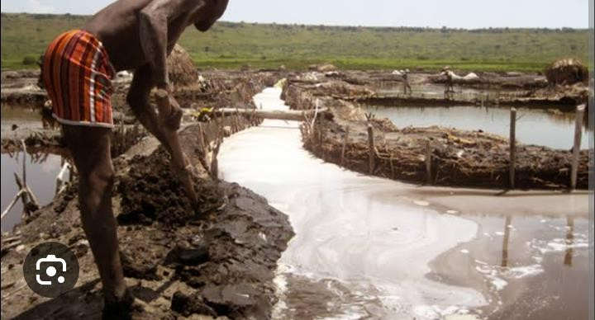

1. Suggest three ways in which salts can be prepared in the laboratory school.

(03 scores)

1. Ammonium chloride is an example of the salts prepared from the laboratory. When it was dissolved in water and the solution tested, it was found to be acidic. Explain why the solution was acidic. (02 scores)
2. State three other applications of salts in your community. (03 scores)
3. Chemistry is one of the most prestigious science subjects studied at the secondary level of Education. When you study chemistry, you not only acquire knowledge about many chemical reactions and other substances, but you can also take up various careers after school.



(a) Identify any three careers that you can take up through studying chemistry.

(03 scores)

b) Briefly describe how the knowledge of chemistry has been applied in the following field in the Ugandan economy;

1. Agriculture. (03 scores)
2. Medicine. (02 scores)
3. Cosmetics industry. (02 scores)
4. Read carefully below about how members of Sarah’s family started their day.

Nakato Swabulah woke up one day late than usual. She was hearing her mum’s loud voice telling her to make tea. When she moved out of the bed, she met her younger brother who was so dirty after playing in mud earlier morning. She removed his dirty clothes and washed them using detergents. She also bathed her young brother using a bathing soap. As she was moving to the kitchen, her father called her and asked her to clean her shoes. She polished her father’s shoes using a new shoe polish they bought from the market. She then went to the kitchen in order to make tea in the kettle. She observed bubbles of boiling water which produced steam in the kettle. She then added tea leaves which changes the entire colour of hot water. She tested the tea but it was so bitter. She then added sugar which made the tea sweet. She poured the tea in the flask and took it in the leaving room where she saw her mother putting fruits and soda in the refrigerator. She started feeling headache. When her mother knew about the headache, she gave her pain killer tablets which made her feel better after a few minutes. She moved out of the house and saw their neighbor painting his old metallic door which had developed a brown coat. (10 scores)



a) Outline activities at Nakato’s home showing chemistry. Give all

1. Identify the occupation.
2. How is the knowledge of chemistry used in that occupation?
3. How is the activity above useful to the society
4. SSentongo Rayan, a S.1 learner has studied Chemistry for two months now, her mother is a senior researcher. On visitation day Rayan and her mother had a lengthy talk about science subjects offered in the school; their relevance in daily life and contributions to the economy. Chemistry being one of those subjects.

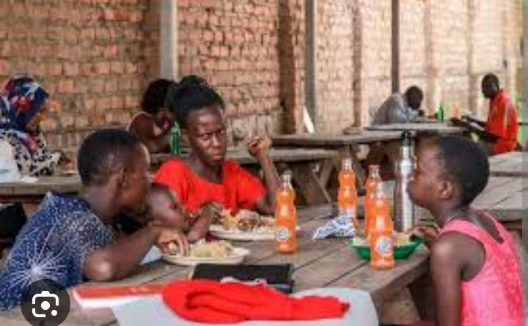

Show how best Rayan would show his father that chemistry has contributed to the economic growth of the country. (10 scores)

1. Kawuki Enock lives along the channels of a water body which supplies the entire village of Masajja with water. He has many cows which drink and move within the water body. He has a big plantation of crops next to the water body on which he uses a massive amount of fertilizes to ensure that he get high yields. He normally cools his machines in water and his wife earns a living by washing clothes daily for people in Masajja. The wife uses detergents and soap to wash the clothes.

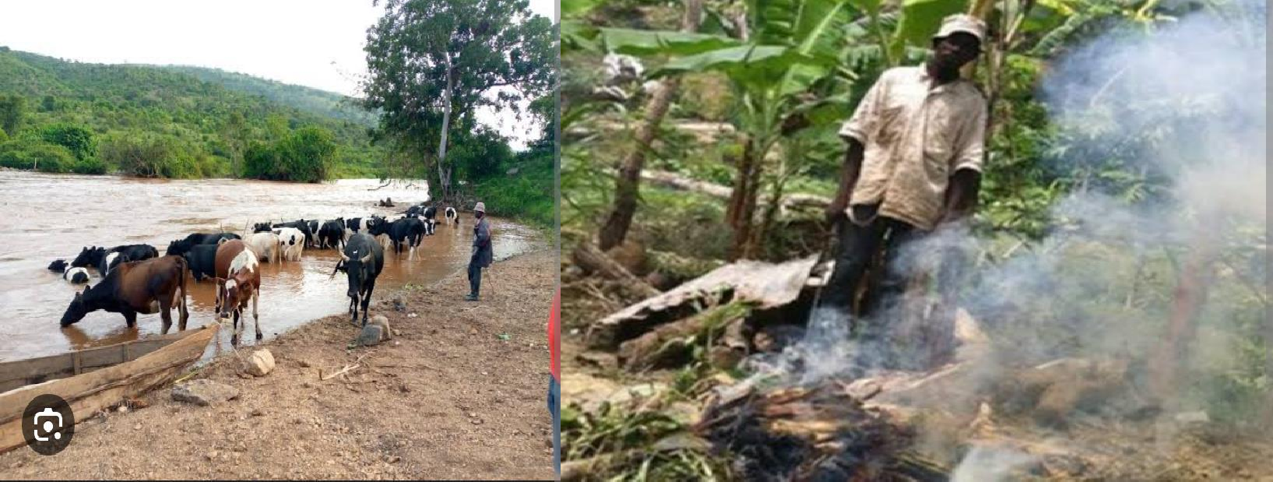

Write a piece of advise to Kawuki Enock letting him know about the ways his family and activities pollute the water body, the possible effects the pollution could do to Masajja and how he can participate in solving the problem of water pollution in the area. (15 scores)

1. Nansubuga Agnes is a student in St. Catherine’s College in Kampala district. When in the chemistry class, Madam Biira taught her that melting of candle wax when a candle is burning is a physical change. The teacher told them to go and research more from a particular book in the library about chemical and physical changes. On reading the book, she found that a burning candle has both physical and chemical changes. Agnes wondered which chemical change is in the burning candle since their teacher had only said that a burning candle has only physical change. When she went back home, she saw the uncle splitting firewood into small pieces. At the same time, her mother was using the splitted pieces of wood to cook food.

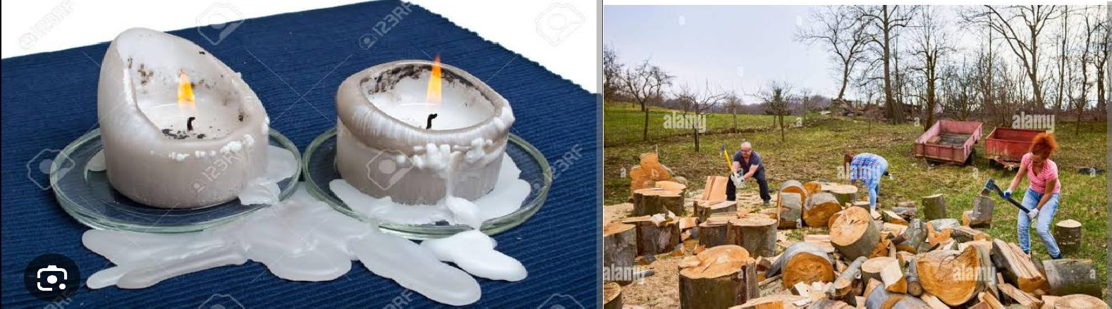

## END

**DIVINE SECONDARY SCHOOL KITALA**

**Uganda Certificate of Lower Secondary Education**

# PHYSICS HOLIDAY WORK 2024

1. Mr. Onyango and Mr.Oketcho had an argument over the width of the path that separates their land. Mr. Onyango claimed that the path is 12 feet wide. However, Mr.Oketcho claimed it was 10 feet. When the chairman intervened, he measured the path with a foot rule and found out that it was 8 feet, after that the three were in disagreement.

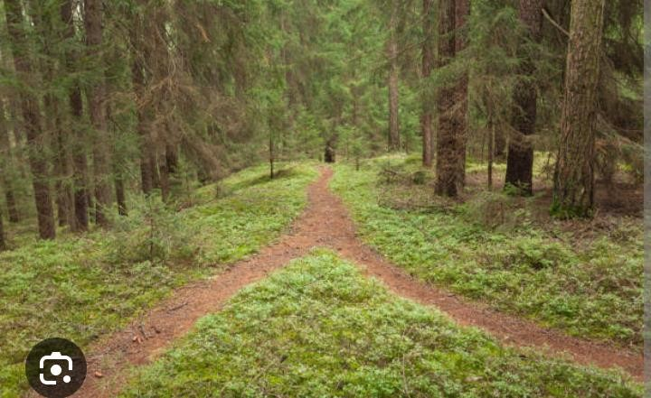

* 1. Why did Mr. Onyango and Mr.Oketcho fail to agree on the width of their path? (01score)
  2. Why do you think the chairman got a different measurement?

(01score)

* 1. As a physics learner, how would you solve the disagreement?

(02 scores)

1. A heap of weed of mass 3 Tonnes is moving towards the turbines at the Jinja power station. A group of engineers needs to use a machine operating at 20 KW for five minutes to remove the weed from the river and place it at the bank which is 15 M above the river.

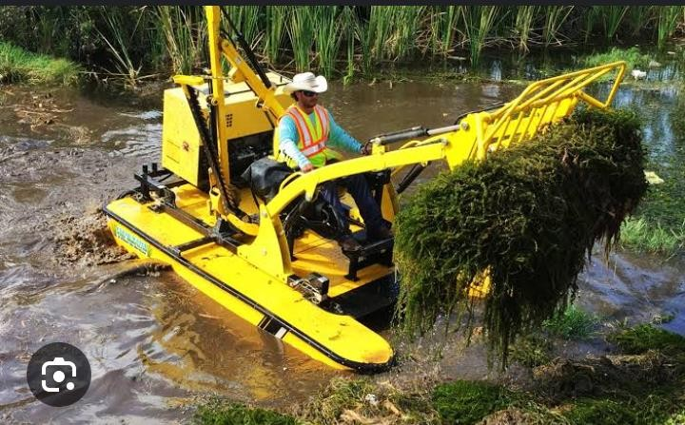

* 1. Determine the efficiency of the machine. (4 scores)
  2. Comment on the efficiency of the machine. (1 score)

1. On a hot day, a student dropped three ice cubes at -6 oC in a jug of water at room temperature. If the final temperature of the mixture after all the ice has melted was 16 oC



* 1. Sketch a temperature-time graph for the ice. (1 score)
  2. Describe the key features of your graph in (i) above. (3 scores)

1. Your elder sister has just received his S.6 results and she scored **AAA** in her combination **PCM**. He is soon going to apply for a course on Bachelors’ degree level at Uganda’s greastest University, Makerere. However, your sister is not sure of which career path he should apply for. He needs some one to guide her through the right career opportunity she can persue in future.

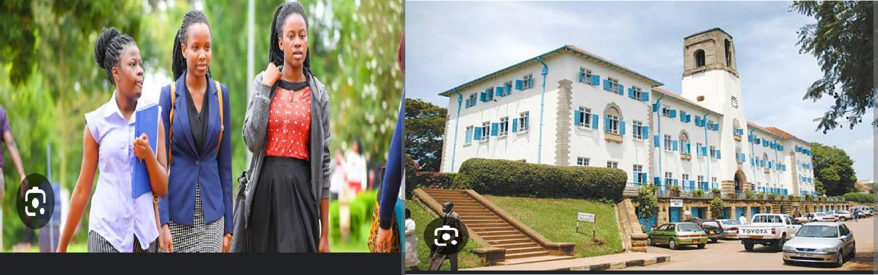

* 1. Write down how you can help your sister in identifying all possible suitable physics careers she can Pursue at the Makerere University.
  2. Identify the likely challenges and benefits in some of the careers available.

1. One rainy day one of your community members was struck by lightning and his body was having third degree skin burns and deep wounds. Most community members claimed it was witchcraft, maybe they are right or there maybe another better explanation to this scenario using knowledge of states of matter.

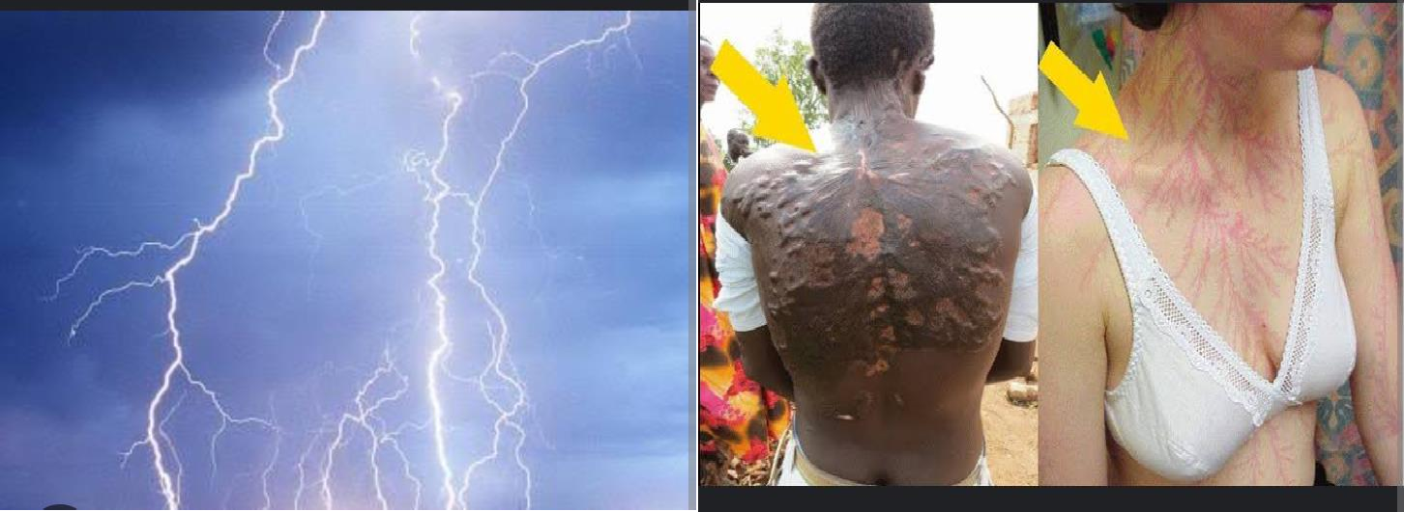

* 1. Explain to the community members what state of matter lightening is giving three more examples of other substances that fall in the same state of matter as lightening (05 scores )

**6.** When a 𝑉𝐻𝑇 (𝑉𝑖𝑙𝑙𝑎𝑔𝑒 𝐻𝑒𝑎𝑙𝑡ℎ 𝑇𝑒𝑎𝑚) member visited a patient in Kamwokya Hospital, he had to determine the temperature of the patient before giving the medication.



1. As a medical doctor, help the VHT member to identify the points of reference that can help him to calibrate the instrument he has to use to determine the patient’s body temperature. (02 scores)
2. The VHT member used mercury in glass thermomometer. As a physicist, identify the physical property used by this thermometer.

(01 score)

1. Why do you think the VHT member chose mercury instead of Alcohol as a thermometric liquid? (Give one reason) (01 score)
2. In your community, there is a village man moving around selling four different objects claiming they are made of Gold. Each object has a known mass. The objects are a tin cylinder, a container cube, a steel spanner and a slicing board.

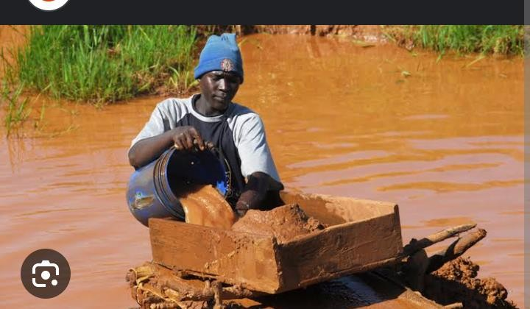

Mugisha wants to buy items for home use but he is not sure where what is buying is purely gold. Help Mugisha make a better choice. (05 scores)

1. A barber was given a curved mirror of focal length 30 cm so that he could use it as a shaving mirror in his saloon.



* 1. Identify the type of curved mirror given to the barber ( 2 scores)
  2. Use a ray diagram to illustrate the use of the selected curved mirror as a shaving mirror (05 scores)
  3. What are the properties of the image formed above? ( 03 scores)

1. . Your uncle operates one of the largest supermarkets in Hoima city however he has been having some challenges especially theft of his goods in his supermarket.



What advice would you offer him using the knowledge of reflection of light to overcome such losses due to theft of his goods. (07 scores)

1. There is a parent project in your school to construct two rectangular pit latrines . one at the girls ‘ wing and another at the staff quarter’ s wing . However , the Board of Governors and the school administration have failed to agree on the choice of materials to use in construction .

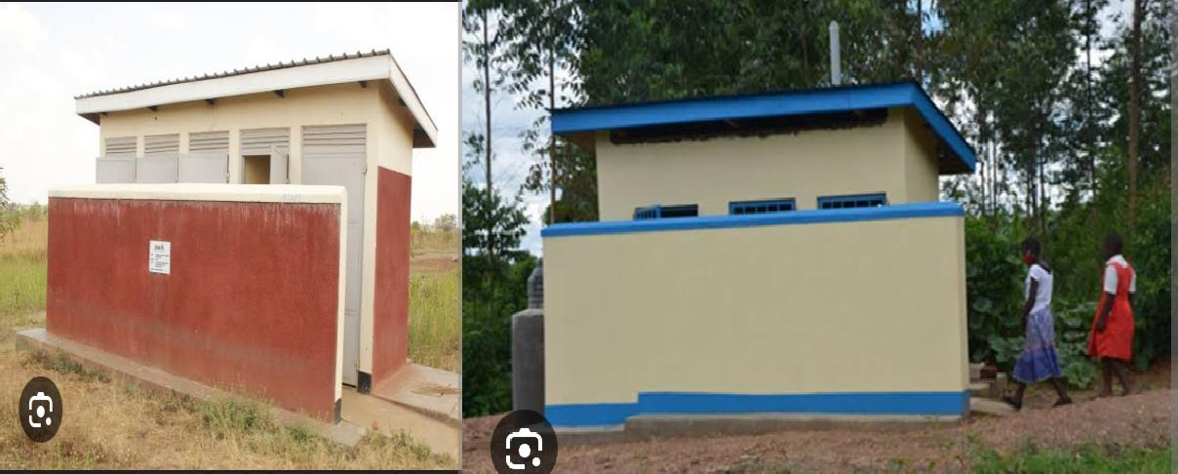

* 1. using the knowledge and skills learnt in ‘’mechanical properties of materials’’ Suggest the choice of materials you would advice the school board to use in the construction of the latrines (8 scores )

1. Mukisa is a senior two learner and he needs a personal revision timetable suitable for 10 subjects.



1. Help Mukisa to make a timetable (02 scores)
2. Find the total number of lessons per week in that timetable (3scores)
3. Find the total time that he will spend in class per day in
4. Hours (2 scores)
5. Minutes. (3 scores)

## DIVINE SECONDARY SCHOOL KITALA

**Uganda Certificate of Lower Secondary Education**

# MATHS HOLIDAY WORK 2024

1. Mugabi wants to make cakes for the learners to eat as accompaniments during break time, the cost of making each cake is (𝑐 + 500) if he wants to make c cakes and he doesn’t want to make any loss but the cost of the raw materials is 60,000/= Find the value of c

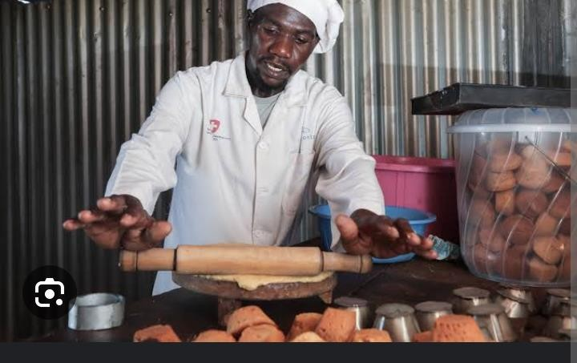

How many cakes can fit on the tray if each cake has a circular base of

uniform diameter of 6cm. (6 scores)

1. In an attempt to comply with government’s guidelines of washing hands regularly with soap to manage corona virus, an Organisation wants to provide tanks to your community Support. Each support frame should be 3m long, 2m wide and 1m high. If the fabricator wants to manufacture the tank, with diagonals AC, BH, AC and BD.

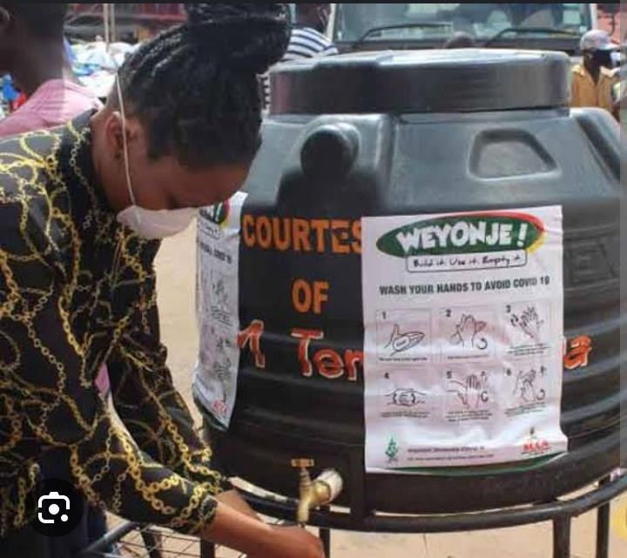

a) Help and advise him on the lengths he should use. (5 scores)

1. The food provider of a school located in Kira Municipality is required to buy food stuffs for a school party. The foodstuffs to be bought include: 100 kg of rice, 150kg of meat and 200kg of Irish potatoes. The cost is UGX 4000, UGX18,000, and UGX1500 per kg of rice, meat and Irish potatoes respectively in kyaliwajara market. The same items cost UGX. 2500, UGX. 14,000 and UGX. 1,200 per kg of rice, meat and Irish potatoes respectively, in Gayaza market. To hire a pick-up from Kyaliwajara market to school costs UGX 50,000 while a pick-up hire from Gayaza farmers’ market is UGX100,000.

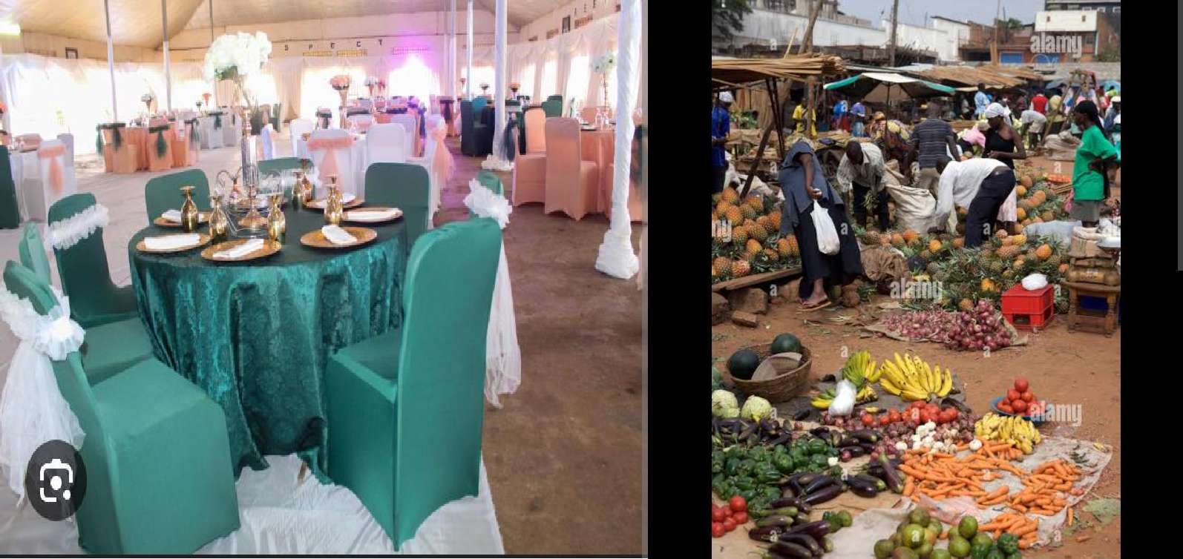

* 1. Using the information provided above, how would the food provider decide on where to do the shopping from? Justify your answer.

(08 scores)

1. Kato asked his teacher how old he was. To confuse him, the teacher told him that “I am 1212 years old”. But after seating alone for some time, he realized that the teacher actually told him his age but in a different number system.

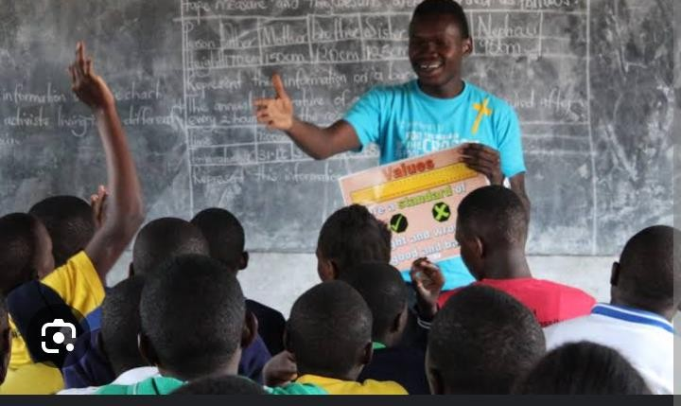

1. What Number system do you think the teacher used and why do you think that way? (2 scores)
2. How old is the teacher? (4 scores)
3. Five friends Apiyo, Asiimwe, Babirye, Namono and Namuli have their first names as Babra, Cathy, Kevin, Mercy and Prisca. When they are together for a swimming game, they keep using their surnames and first names interchangeably. The sports trainer gets confused so that he cannot correctly establish both names for a person.



One day, somebody got information on a sheet of paper written as

* Apiyo went swimming with Prisca, Babra and Cathy.
* Namono travelled to Nairobi with Prisca and Cathy.
* Asiimwe, Babirye, Prisca and Mercy went for a meeting in Dubai.
* Mercy, Apiyo and Namuli visited Asiimwe.
* Babirye and Cathy went shopping. Resources Knowledge of relations and mapping.
  1. Advise the sports trainer on how he can match the two names of an individual correctly. (08 scores)

1. Your family has five siblings, Kato, Alex, David, Tracy and Esther. There is an interval of three years between the ages of the children, from Esther to Kato.

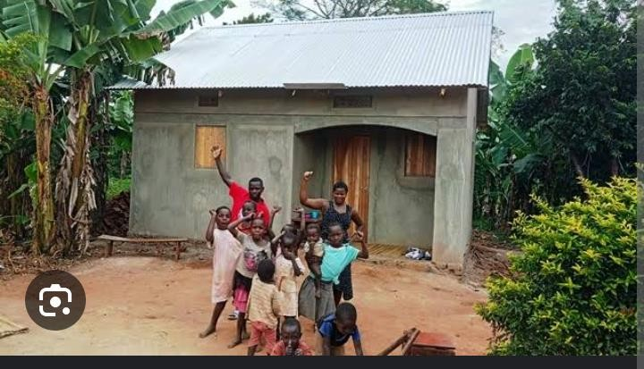Kato is 4 years old.

Using an arrow diagram, explain the information about your family.

(06 scores)

1. 5 loan officers started a micro finance business and they intend to reach as many clients as possible. Each officer was tasked to reach to 5 more clients and each client has to reach out to 5 other clients in 1 week.



* 1. Approximate the number of members in the 3rd week if all members managed to get the required number of clients. (08 scores)

1. On April 4, 2020 the Covid19 task force started the distribution of food in Kawempe Division in Kampala district. Each member in the household

was given a package containing 6 kgs of maize floor and 3 kg of beans. There are 10 households in the community with 3, 5, 7, 4, 6, 5,8,12, 13 and 4 members respectively.

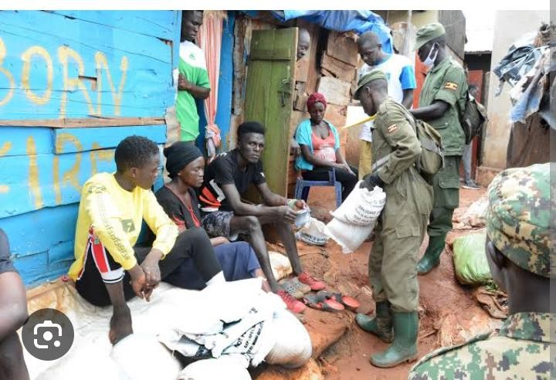

## TASK

1. Determine the number of packages the task force distributed in kawempe division. ( 2 scores)
2. Determine the total weight of the maize our that was distributed in the division. ( 3 scores)
3. In case there are some remaining packages,discuss what the task force should do with them. (3 scores)
4. The prices of, beans and maize our was approximated to be at 4000UGX and 2500UGX per kilogram respectively. What is the total amount of money spent by the government on maize our and beans in the 10 households. (4 scores)
5. Stephen is planning a graduation party and wants to give his guests some snacks on arrival for the party. He buys 72 cup cakes,144 apples and 288 chocolate bars



* Support: Each plate must have exactly the same number of chocolate bars, apples, and cupcakes .There must not be any left overs.
* Knowledge: Knowledge of factors, highest common factor and numbers

## TASK:

What is the greatest number of guests stephen must invite for the graduation party. (06 scores)

1. Taibah international school has two sections, that is, Lower UNEB (S.1-S.4) and Upper UNEB (S.5-S.6).

The Director of studies of the school needs to draw a timetable for the online lessons for both sections. The sections should start and end their morning lessons at the same time before break time, start and end their break time at the

same time. The after break lessons should start at the same time. The lunchtime for both sections should start at the same time and end at the same time.

The after Lunch lessons should start at the same time and end at the same time.Math must have 3 hours in a week in each class

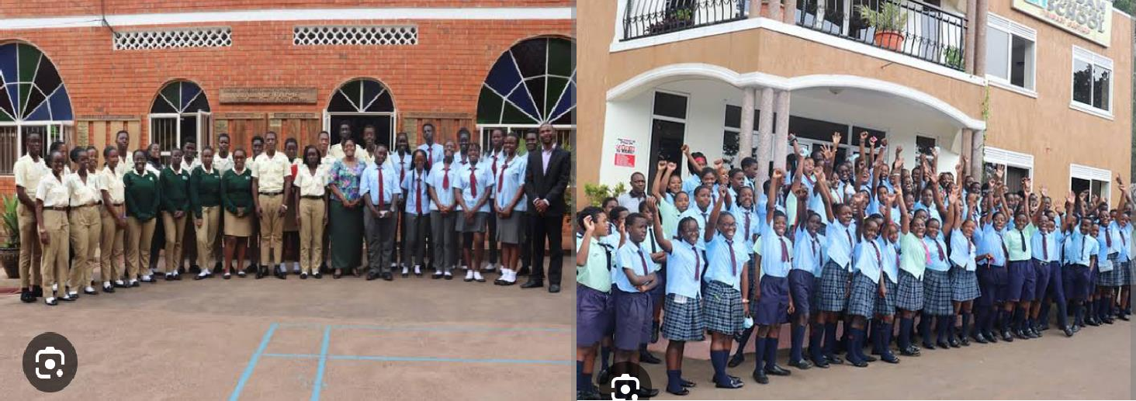

* + **Support:** The time to start lessons for the two sections is 8.30am and lessons end at 4:30pm. The duration of the lesson for the Lower UNEB section is 1 hour and that of the Upper UNEB is 2 hours. Assume the following subjects to be oared Math English History Art Geography CRE Music Biology Chemistry Physics Entrepreneurship Home mgt Psychology and P.E
  + **Resources:** Knowledge of fractions, percentages, natural numbers, factors, multiples, lowest common multiples, and the subjects taught in all classes and of time.

## TASKS:

1. Help the Director of studies by drawing the timetable for the week (monday to friday) for the two sections. (04 scores)
2. How many lessons does each section have up to lunchtime? (03 scores)
3. What is the total number of hours in a week for the lower section. (03 scores)
   1. Senior One learner has reported in her class and has settled at her desk.

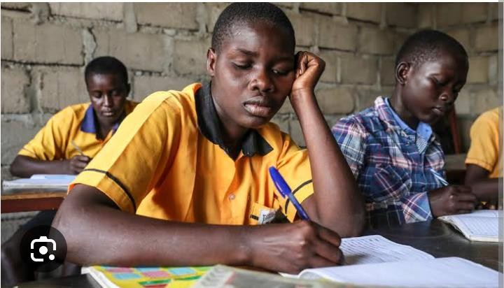

* + - **Support**: The classroom is arranged in rows and columns. It is a big class with each learner having his/ her own desk
    - **Resources**: Knowledge of horizontal and vertical lines i.e. rows and columns, coordinates
    - **Knowledge**: counting numbers

## TASK:

The mathematics teacher has asked her to explain how she can access her seat, starting from the entrance of the class. Discuss whether there are other ways of reaching her seat. ( 08 scores)

1. In a village, there is an old man who wants to construct a rectangular small house of wattle and mud.

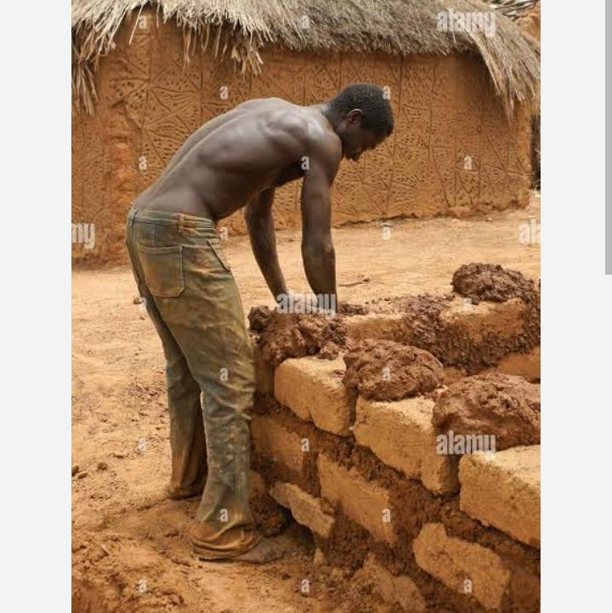

## TASK:

* **Support:** A string, sticks, panga, tape measure and human resource.
* **Resources:** Knowledge of horizontal and vertical lines i.e. rows and columns, knowledge of construction of geometric gures

The community asks you to accurately construct the foundation plan for this old man's house.

1. Explain how you have accurately constructed the foundation plan. ( 03 scores)
2. Discuss whether there are other ways of constructing an accurate foundation plan. ( 03 scores)
3. Priscilla is in Kampala City and has been told to use a car to move to Lira town. She has never gone to Lira. She has been given the map of Uganda showing routes through which she can access Lira town.

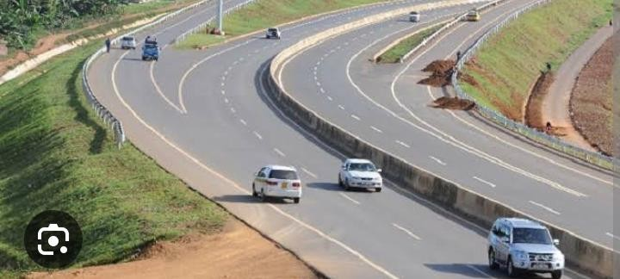

* + Support: Mathematical instruments, pencil, paper, pens, tracing paper and map of Uganda.
  + Resources:Knowledge of construction of gures like triangles, lengths of sides of triangles, operations on numbers

## TASK:

1. Priscilla wants to use the short distance from Kampala to Lira. Explain how Priscilla can determine the shortest distance. (04 scores)
2. Using the map given to her is it possible for Priscilla to use the shortest distance she has determined. Explain your answer. (6 scores)
3. The following districts below shows the Covid 19 active cases discovered in some districts of Uganda in a year 2020.

|  |  |  |
| --- | --- | --- |
| District | Buikwe | 24 |
|  | Elegu | 350 |
|  | Busia | 150 |
|  | Mutukula | 120 |
|  | Malaba | 56 |

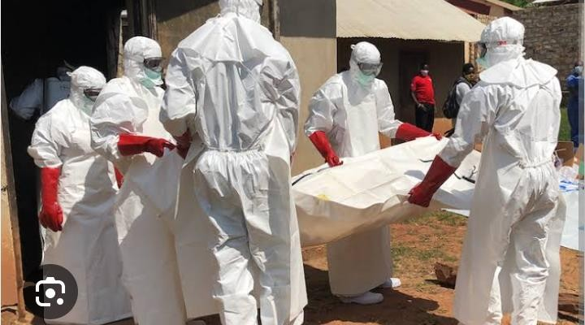

* + **Support**: Mathematical instruments, pencil, paper, pens, set
  + **Resources**: Knowledge of construction of gures like circle and the knowledge of measuring angles

## TASK:

a) The ministry of health was asked to represent the information above on pie chart. As a senior one learner help the ministry to solve the challenge.

(08 scores)

1. The Games Master at your school wants to buy football boots for the three teams in the school. The three teams are the under 18 years, under 16 years and the under 14 years. The Games Master does not know the foot size for each of the players.

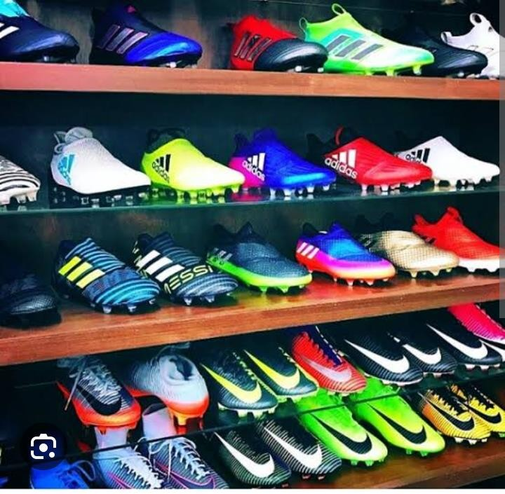

* + **Support**: pens, paper, tape measure, team members
  + **Resources**: Knowledge of tabulation, of tallying, of approximation, of central measures and of collection of suitable data.

## TASKS:

1. The total number of players for the three teams is 54. The Games Master wants to know the size of the boots for each player and the number of pairs for each size. ( 04 scores)
2. Explain how the Games Master will get the required data and how to determine the total cost for buying the football boots for the 54 players.

( 04 scores)

1. Is there another way of getting the required data other than what you have explained above? ( 02 scores)
2. Secondary schools have morning and evening preps .The morning preps start at 5:00am and end at 6:30am, While the evening preps start at 6:15pm and end at 9:15pm.Each science subject must have 2hours on the time table

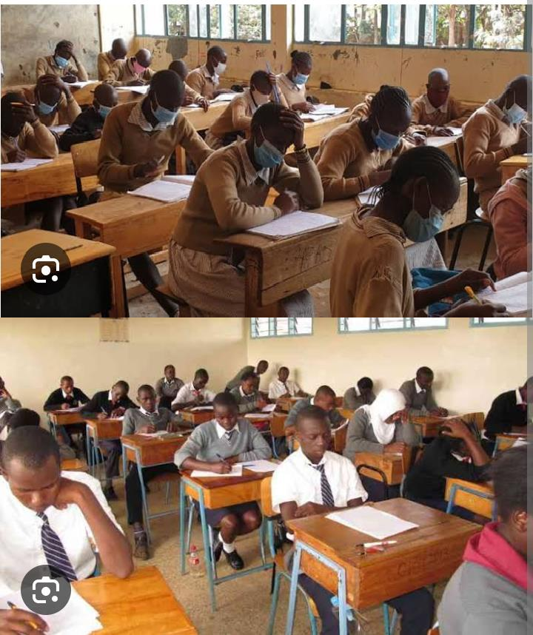

* + Support: Mathematical instruments, pencil, paper, pens,colors
  + Resources:Knowledge of time tables,time,subjects

## TASK:

As a senior one learner ,design a personal time table, clearly indicating the time given to each subject and the day of the week. (08 scores)

## END